Assignment 4

1.2)

1) Please refer to perceptron.py and PerceptronDataAnalysis(Primal).py

2) Please refer to perceptron.py and PerceptronDataAnalysis(Dual).py

3)

Primal Perceptron:

|  |  |  |  |
| --- | --- | --- | --- |
| Fold | Accuracy | Precision | Recall |
| 1 | 0.96 | 0.96 | 0.96 |
| 2 | 0.93 | 0.93 | 0.93 |
| 3 | 0.98 | 0.98 | 0.98 |
| 4 | 0.93 | 0.93 | 0.93 |
| 5 | 0.98 | 0.98 | 0.98 |
| 6 | 0.92 | 0.92 | 0.92 |
| 7 | 0.95 | 0.95 | 0.95 |
| 8 | 0.93 | 0.93 | 0.93 |
| 9 | 0.97 | 0.97 | 0.97 |
| 10 | 1 | 1 | 1 |
| Average | 0.955 | 0.955 | 0.955 |
| SD | 0.027183 | 0.027183 | 0.027183 |

Dual Perceptron:

|  |  |  |  |
| --- | --- | --- | --- |
| Fold | Accuracy | Precision | Recall |
| 1 | 0.96 | 0.96 | 0.96 |
| 2 | 0.93 | 0.93 | 0.93 |
| 3 | 0.98 | 0.98 | 0.98 |
| 4 | 0.93 | 0.93 | 0.93 |
| 5 | 0.98 | 0.98 | 0.98 |
| 6 | 0.92 | 0.92 | 0.92 |
| 7 | 0.95 | 0.95 | 0.95 |
| 8 | 0.93 | 0.93 | 0.93 |
| 9 | 0.97 | 0.97 | 0.97 |
| 10 | 1 | 1 | 1 |
| Average | 0.955 | 0.955 | 0.955 |
| SD | 0.027183 | 0.027183 | 0.027183 |

1.3)

1)

Linear Kernel Dual Perceptron:

Please refer to dualperceptron.py and TwoSpiralLinearKernel.py

|  |  |  |
| --- | --- | --- |
| Fold | Accuracy | Recall |
| 1 | 0.653922 | 0.62 |
| 2 | 0.669474 | 0.63 |
| 3 | 0.810119 | 0.71 |
| 4 | 0.2809 | 0.53 |
| 5 | 0.2916 | 0.54 |
| 6 | 0.619459 | 0.58 |
| 7 | 0.5824 | 0.55 |
| 8 | 0.776 | 0.66 |
| 9 | 0.660528 | 0.66 |
| 10 | 0.610522 | 0.55 |
| Average | 0.595492 | 0.603 |
| SD | 0.177656 | 0.061833 |

2)

RBF Kernel Dual Perceptron:

Please refer to dualperceptron.py and TwoSpiralRBF.py

|  |  |  |
| --- | --- | --- |
| Fold | Accuracy | Recall |
| 1 | 0.684231 | 0.68 |
| 2 | 0.730507 | 0.73 |
| 3 | 0.643778 | 0.64 |
| 4 | 0.644625 | 0.64 |
| 5 | 0.639636 | 0.63 |
| 6 | 0.66069 | 0.66 |
| 7 | 0.714956 | 0.71 |
| 8 | 0.65291 | 0.65 |
| 9 | 0.66 | 0.66 |
| 10 | 0.648557 | 0.64 |
| Average | 0.667989 | 0.664 |
| SD | 0.031686 | 0.033066 |

For the search strategy, I checked the algorithm for different values of lambda and found that the best value of lambda to be 0.15.

Comparing the above two tables, RBF kernel has more consistent accuracy and better average accuracy and standard deviation than linear Kernel.

2)

1) W0 can be eliminated for regularized logistic regression as we are adding a penalty to the optimization problem.

2,3) Please refer attached theoryquestions.pdf

4)Please refer the folder Logistic Regression

Spam Base Regularized:

|  |  |  |
| --- | --- | --- |
| Fold | Accuracy | Recall |
| 1 | 0.911731 | 0.911063 |
| 2 | 0.932599 | 0.932609 |
| 3 | 0.913038 | 0.913043 |
| 4 | 0.904619 | 0.902174 |
| 5 | 0.934638 | 0.934783 |
| 6 | 0.904464 | 0.904348 |
| 7 | 0.919267 | 0.919565 |
| 8 | 0.919401 | 0.919565 |
| 9 | 0.931897 | 0.930435 |
| 10 | 0.934711 | 0.934783 |
| Average | 0.920636 | 0.920237 |
| SD | 0.012122 | 0.012453 |

Normal:

|  |  |  |
| --- | --- | --- |
| Fold | Accuracy | Recall |
| 1 | 0.911731 | 0.911063 |
| 2 | 0.923839 | 0.923913 |
| 3 | 0.910909 | 0.91087 |
| 4 | 0.904619 | 0.902174 |
| 5 | 0.934638 | 0.934783 |
| 6 | 0.904464 | 0.904348 |
| 7 | 0.919267 | 0.919565 |
| 8 | 0.91725 | 0.917391 |
| 9 | 0.931897 | 0.930435 |
| 10 | 0.934711 | 0.934783 |
| Mean | 0.919332 | 0.918932 |
| Standard Deviation | 0.011043 | 0.011326 |

Diabetes Regularized:

|  |  |  |
| --- | --- | --- |
| Fold | Accuracy | Recall |
| 1 | 0.810922 | 0.805195 |
| 2 | 0.749941 | 0.753247 |
| 3 | 0.764396 | 0.766234 |
| 4 | 0.776361 | 0.779221 |
| 5 | 0.787765 | 0.792208 |
| 6 | 0.806848 | 0.805195 |
| 7 | 0.663315 | 0.688312 |
| 8 | 0.750861 | 0.753247 |
| 9 | 0.786115 | 0.789474 |
| 10 | 0.769549 | 0.776316 |
| Average | 0.766607 | 0.770865 |
| SD | 0.041786 | 0.034506 |

Normal:

|  |  |  |
| --- | --- | --- |
| 1 | 0.810922 | 0.805195 |
| 2 | 0.749941 | 0.753247 |
| 3 | 0.764396 | 0.766234 |
| 4 | 0.776361 | 0.779221 |
| 5 | 0.787765 | 0.792208 |
| 6 | 0.806848 | 0.805195 |
| 7 | 0.663315 | 0.688312 |
| 8 | 0.750861 | 0.753247 |
| 9 | 0.786115 | 0.789474 |
| 10 | 0.769549 | 0.776316 |
| Mean | 0.766607 | 0.770865 |
| Standard | 0.039642 | 0.032735 |

Breast Cancer Regularized:

|  |  |  |
| --- | --- | --- |
| Fold | Precision | Recall |
| 1 | 0.964912 | 0.964912 |
| 2 | 0.98338 | 0.982456 |
| 3 | 1 | 1 |
| 4 | 0.966809 | 0.964912 |
| 5 | 0.947638 | 0.947368 |
| 6 | 1 | 1 |
| 7 | 0.948224 | 0.947368 |
| 8 | 0.982988 | 0.982456 |
| 9 | 1 | 1 |
| 10 | 0.982639 | 0.982143 |
| Mean | 0.977659 | 0.977162 |
| Standard | 0.019056 | 0.01929 |

Normal:

|  |  |  |
| --- | --- | --- |
| Fold | Precision | Recall |
| 1 | 0.964912 | 0.964912 |
| 2 | 0.98338 | 0.982456 |
| 3 | 1 | 1 |
| 4 | 0.966809 | 0.964912 |
| 5 | 0.947638 | 0.947368 |
| 6 | 1 | 1 |
| 7 | 0.948224 | 0.947368 |
| 8 | 0.982988 | 0.982456 |
| 9 | 1 | 1 |
| 10 | 0.982639 | 0.982143 |
| Mean | 0.977659 | 0.977162 |
| Standard | 0.019056 | 0.01929 |

The regularized Logistic Regression performs either better or same as that of normal logistic Regression.

5) Please refer attached theoryquestions.pdf

3)

1)

**Optimizing accuracy:**

**Diabetes:**

RBF:

|  |  |  |  |
| --- | --- | --- | --- |
| Fold | C | gamma | score |
| 1 | 16 | 0.003906 | 0.77 |
| 2 | 1 | 0.125 | 0.78 |
| 3 | 32 | 0.001953 | 0.77 |
| 4 | 256 | 0.000488 | 0.77 |
| 5 | 2 | 0.03125 | 0.77 |
| 6 | 1 | 0.03125 | 0.77 |
| 7 | 512 | 0.000488 | 0.78 |
| 8 | 4 | 0.03125 | 0.78 |
| 9 | 2 | 0.03125 | 0.78 |
| 10 | 2 | 0.03125 | 0.77 |

Linear:

|  |  |  |
| --- | --- | --- |
| Fold | C | score |
| 1 | 1 | 0.77 |
| 2 | 0.25 | 0.77 |
| 3 | 0.25 | 0.77 |
| 4 | 0.125 | 0.77 |
| 5 | 8 | 0.77 |
| 6 | 0.0625 | 0.77 |
| 7 | 32 | 0.79 |
| 8 | 0.03125 | 0.77 |
| 9 | 8 | 0.77 |
| 10 | 0.25 | 0.77 |

|  |  |  |  |  |  |  |
| --- | --- | --- | --- | --- | --- | --- |
| Training | | | | | | |
| Kernel | Accuracy(Mean) | Accuracy(Std) | Precision(Mean) | Precison(Std) | Recall(mean) | Recall(Std) |
| RBF | 0.793113148 | 0.014271162 | 0.594068503 | 0.238428417 | 0.57995518 | 0.02003 |
| Linear | 0.780381955 | 0.007400138 | 0.572411853 | 0.013134992 | 0.57033956 | 0.021026 |

|  |  |  |  |  |  |  |
| --- | --- | --- | --- | --- | --- | --- |
| Kernel | Accuracy(Mean) | Accuracy(Std) | Precision(Mean) | Precison(Std) | Recall(mean) | Recall(Std) |
| RBF | 0.756578947 | 0.037702203 | 0.535330793 | 0.070709324 | 0.52376569 | 0.072676 |
| Linear | 0.770847573 | 0.033363278 | 0.556820473 | 0.081383361 | 0.54517562 | 0.071028 |

Optimizing AUC:

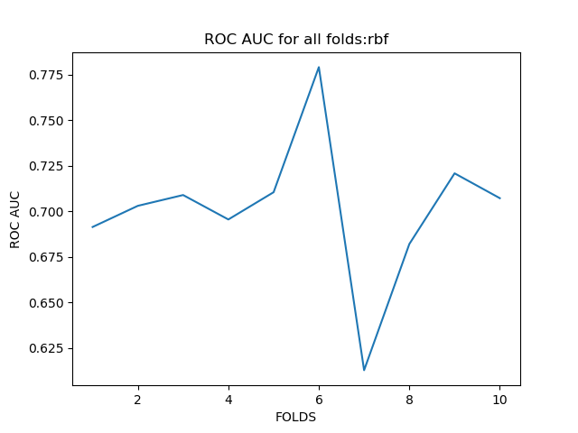 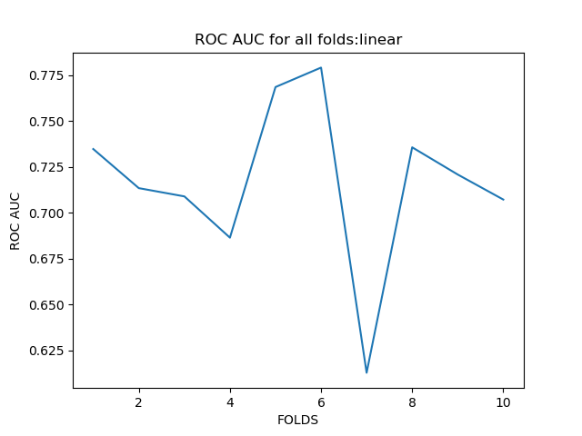

**BreastCancer :**

**Optimizing accuracy:**

Executing kernel: rbf

Executing Fold 1

The best parameters are {'C': 16, 'gamma': 0.03125} with a score of 0.98

Train Accuracy: 0.99609375

Train Precision: 0.9935969716494846

Train Recall: 0.9896907216494846

test Accuracy: 0.9649122807017544

test Precision: 0.9239766081871345

test Recall: 0.8888888888888888

Executing Fold 2

The best parameters are {'C': 32, 'gamma': 0.0078125} with a score of 0.98

Train Accuracy: 0.98828125

Train Precision: 0.9807909149484536

Train Recall: 0.9690721649484536

test Accuracy: 0.9649122807017544

test Precision: 0.9095191682910981

test Recall: 0.9444444444444444

Executing Fold 3

The best parameters are {'C': 2, 'gamma': 0.015625} with a score of 0.97

Train Accuracy: 0.984375

Train Precision: 0.9741742227979274

Train Recall: 0.9585492227979274

test Accuracy: 0.9824561403508771

test Precision: 0.95

test Recall: 1.0

Executing Fold 4

The best parameters are {'C': 64, 'gamma': 0.00390625} with a score of 0.98

Train Accuracy: 0.990234375

Train Precision: 0.9834498355263158

Train Recall: 0.9736842105263158

test Accuracy: 0.9649122807017544

test Precision: 0.9441786283891547

test Recall: 0.9090909090909091

Executing Fold 5

The best parameters are {'C': 64, 'gamma': 0.00390625} with a score of 0.98

Train Accuracy: 0.98828125

Train Precision: 0.9778796398011101

Train Recall: 0.973404255319149

test Accuracy: 0.9649122807017544

test Precision: 0.9359466374269007

test Recall: 0.9583333333333334

Executing Fold 6

The best parameters are {'C': 128, 'gamma': 0.00048828125} with a score of 0.98

Train Accuracy: 0.98046875

Train Precision: 0.9631078375286041

Train Recall: 0.9578947368421052

test Accuracy: 1.0

test Precision: 1.0

test Recall: 1.0

Executing Fold 7

The best parameters are {'C': 64, 'gamma': 0.0009765625} with a score of 0.99

Train Accuracy: 0.98828125

Train Precision: 0.9798038563829787

Train Recall: 0.9680851063829787

test Accuracy: 0.9473684210526315

test Precision: 0.9118993135011442

test Recall: 0.9166666666666666

Executing Fold 8

The best parameters are {'C': 256, 'gamma': 0.000244140625} with a score of 0.98

Train Accuracy: 0.984375

Train Precision: 0.9690548886283276

Train Recall: 0.9679144385026738

test Accuracy: 0.9824561403508771

test Precision: 0.9775438596491228

test Recall: 0.96

Executing Fold 9

The best parameters are {'C': 256, 'gamma': 0.000244140625} with a score of 0.98

Train Accuracy: 0.984375

Train Precision: 0.9703776309386737

Train Recall: 0.9689119170984456

test Accuracy: 1.0

test Precision: 1.0

test Recall: 1.0

Executing Fold 10

The best parameters are {'C': 8, 'gamma': 0.0078125} with a score of 0.98

Train Accuracy: 0.9883040935672515

Train Precision: 0.9802822938673035

Train Recall: 0.9685863874345549

test Accuracy: 0.9821428571428571

test Precision: 0.9702380952380952

test Recall: 0.9523809523809523

TRAINING RESULTS

Average Accuracy across all folds 0.9873069718567251

Standard deviation Accuracy across all folds 0.004027030168462347

Average Precision across all folds 0.9772518092069179

Standard deviation Precision across all folds 0.008112727008086455

Average Recall across all folds 0.969579316150209

Standard Deviation Accuracy across all folds 0.008371584756117835

TESTING RESULTS

Average Accuracy across all folds 0.9754072681704262

Standard deviation Accuracy across all folds 0.016065809254706857

Average Precision across all folds 0.9523302310682649

Standard deviation Precision across all folds 0.03180079758581333

Average Recall across all folds 0.9529805194805195

Standard Deviation Accuracy across all folds 0.03759837143259275

Executing kernel: linear

Executing Fold 1

The best parameters are {'C': 0.25} with a score of 0.97

Train Accuracy: 0.984375

Train Precision: 0.9705901553174172

Train Recall: 0.9690721649484536

test Accuracy: 0.9649122807017544

test Precision: 0.9239766081871345

test Recall: 0.8888888888888888

Executing Fold 2

The best parameters are {'C': 0.125} with a score of 0.97

Train Accuracy: 0.982421875

Train Precision: 0.9673892153152784

Train Recall: 0.9639175257731959

test Accuracy: 1.0

test Precision: 1.0

test Recall: 1.0

Executing Fold 3

The best parameters are {'C': 0.0625} with a score of 0.97

Train Accuracy: 0.982421875

Train Precision: 0.9690207323527773

Train Recall: 0.9585492227979274

test Accuracy: 0.9824561403508771

test Precision: 0.95

test Recall: 1.0

Executing Fold 4

The best parameters are {'C': 0.5} with a score of 0.98

Train Accuracy: 0.9921875

Train Precision: 0.9848347389417692

Train Recall: 0.9842105263157894

test Accuracy: 0.9649122807017544

test Precision: 0.9441786283891547

test Recall: 0.9090909090909091

Executing Fold 5

The best parameters are {'C': 0.25} with a score of 0.98

Train Accuracy: 0.98828125

Train Precision: 0.9778796398011101

Train Recall: 0.973404255319149

test Accuracy: 0.9649122807017544

test Precision: 0.9359466374269007

test Recall: 0.9583333333333334

Executing Fold 6

The best parameters are {'C': 0.125} with a score of 0.97

Train Accuracy: 0.98046875

Train Precision: 0.9631078375286041

Train Recall: 0.9578947368421052

test Accuracy: 0.9824561403508771

test Precision: 0.9720893141945773

test Recall: 0.9545454545454546

Executing Fold 7

The best parameters are {'C': 0.125} with a score of 0.98

Train Accuracy: 0.98828125

Train Precision: 0.9778796398011101

Train Recall: 0.973404255319149

test Accuracy: 0.9473684210526315

test Precision: 0.9118993135011442

test Recall: 0.9166666666666666

Executing Fold 8

The best parameters are {'C': 1} with a score of 0.98

Train Accuracy: 0.986328125

Train Precision: 0.9724487219541966

Train Recall: 0.9732620320855615

test Accuracy: 0.9824561403508771

test Precision: 0.9775438596491228

test Recall: 0.96

Executing Fold 9

The best parameters are {'C': 2} with a score of 0.98

Train Accuracy: 0.986328125

Train Precision: 0.971785945595855

Train Recall: 0.9792746113989638

test Accuracy: 0.9824561403508771

test Precision: 0.95

test Recall: 1.0

Executing Fold 10

The best parameters are {'C': 1} with a score of 0.98

Train Accuracy: 0.98635477582846

Train Precision: 0.9732087698235105

Train Recall: 0.9738219895287958

test Accuracy: 0.9642857142857143

test Precision: 0.9404761904761905

test Recall: 0.9047619047619048

TRAINING RESULTS

Average Accuracy across all folds 0.9857448525828459

Standard deviation Accuracy across all folds 0.003274520786980225

Average Precision across all folds 0.9728145396431629

Standard deviation Precision across all folds 0.005832134990874496

Average Recall across all folds 0.9706811320329092

Standard Deviation Accuracy across all folds 0.008045243920530647

TESTING RESULTS

Average Accuracy across all folds 0.9736215538847116

Standard deviation Accuracy across all folds 0.014184362143617789

Average Precision across all folds 0.9506110551824223

Standard deviation Precision across all folds 0.02488741784439688

Average Recall across all folds 0.9492287157287158

Standard Deviation Accuracy across all folds 0.040311133448866034

Optimizing AUC:

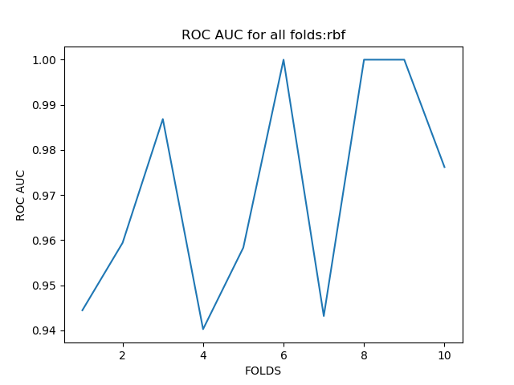

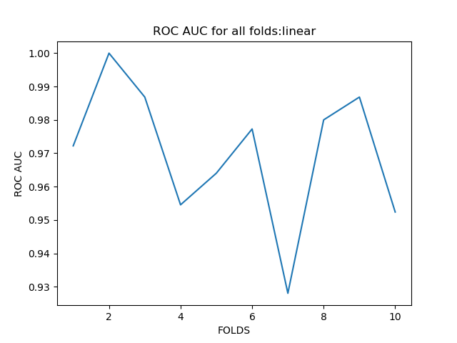

Spambase:

4)

1)

Executing kernel: rbf

Executing Fold 1

The best parameters for model 1 are {'C': 0.25, 'gamma': 0.0625} with a score of 0.99

Test ROC AUC for model1: 1.0

The best parameters gor model 2 are {'C': 1, 'gamma': 0.03125} with a score of 0.99

Test ROC AUC for model2: 1.0

The best parameters for model 3 are {'C': 0.25, 'gamma': 0.03125} with a score of 1.00

Test ROC AUC for model3: 1.0

Train Accuracy: 0.99375

Train Precision: 0.99375

Train Recall: 0.99375

test Accuracy: 1.0

test Precision: 1.0

test Recall: 1.0

Executing Fold 2

The best parameters for model 1 are {'C': 0.25, 'gamma': 0.125} with a score of 0.99

Test ROC AUC for model1: 1.0

The best parameters gor model 2 are {'C': 2, 'gamma': 0.015625} with a score of 0.99

Test ROC AUC for model2: 0.9285714285714286

The best parameters for model 3 are {'C': 2, 'gamma': 0.015625} with a score of 1.00

Test ROC AUC for model3: 1.0

Train Accuracy: 0.99375

Train Precision: 0.99375

Train Recall: 0.99375

test Accuracy: 1.0

test Precision: 1.0

test Recall: 1.0

Executing Fold 3

The best parameters for model 1 are {'C': 0.25, 'gamma': 0.0625} with a score of 0.99

Test ROC AUC for model1: 1.0

The best parameters gor model 2 are {'C': 32, 'gamma': 0.001953125} with a score of 0.99

Test ROC AUC for model2: 0.9500000000000001

The best parameters for model 3 are {'C': 1, 'gamma': 0.015625} with a score of 1.00

Test ROC AUC for model3: 1.0

Train Accuracy: 1.0

Train Precision: 1.0

Train Recall: 1.0

test Accuracy: 1.0

test Precision: 1.0

test Recall: 1.0

Executing Fold 4

The best parameters for model 1 are {'C': 0.25, 'gamma': 0.0625} with a score of 0.99

Test ROC AUC for model1: 1.0

The best parameters gor model 2 are {'C': 16, 'gamma': 0.0078125} with a score of 0.99

Test ROC AUC for model2: 1.0

The best parameters for model 3 are {'C': 0.5, 'gamma': 0.015625} with a score of 1.00

Test ROC AUC for model3: 0.9642857142857143

Train Accuracy: 1.0

Train Precision: 1.0

Train Recall: 1.0

test Accuracy: 1.0

test Precision: 1.0

test Recall: 1.0

Executing Fold 5

The best parameters for model 1 are {'C': 0.125, 'gamma': 0.0625} with a score of 0.99

Test ROC AUC for model1: 0.9166666666666667

The best parameters gor model 2 are {'C': 4, 'gamma': 0.015625} with a score of 0.99

Test ROC AUC for model2: 0.9285714285714286

The best parameters for model 3 are {'C': 0.25, 'gamma': 0.015625} with a score of 1.00

Test ROC AUC for model3: 0.9615384615384616

Train Accuracy: 1.0

Train Precision: 1.0

Train Recall: 1.0

test Accuracy: 0.9444444444444444

test Precision: 0.9444444444444444

test Recall: 0.9444444444444444

Executing Fold 6

The best parameters for model 1 are {'C': 0.25, 'gamma': 0.0625} with a score of 0.99

Test ROC AUC for model1: 1.0

The best parameters gor model 2 are {'C': 2, 'gamma': 0.00390625} with a score of 0.99

Test ROC AUC for model2: 1.0

The best parameters for model 3 are {'C': 0.5, 'gamma': 0.015625} with a score of 1.00

Test ROC AUC for model3: 1.0

Train Accuracy: 0.9875

Train Precision: 0.9875

Train Recall: 0.9875

test Accuracy: 1.0

test Precision: 1.0

test Recall: 1.0

Executing Fold 7

The best parameters for model 1 are {'C': 0.25, 'gamma': 0.0625} with a score of 1.00

Test ROC AUC for model1: 0.9166666666666667

The best parameters gor model 2 are {'C': 1, 'gamma': 0.0625} with a score of 0.99

Test ROC AUC for model2: 0.9583333333333333

The best parameters for model 3 are {'C': 0.5, 'gamma': 0.03125} with a score of 1.00

Test ROC AUC for model3: 1.0

Train Accuracy: 0.99375

Train Precision: 0.99375

Train Recall: 0.99375

test Accuracy: 0.9444444444444444

test Precision: 0.9444444444444444

test Recall: 0.9444444444444444

Executing Fold 8

The best parameters for model 1 are {'C': 1, 'gamma': 0.03125} with a score of 1.00

Test ROC AUC for model1: 1.0

The best parameters gor model 2 are {'C': 0.5, 'gamma': 0.0625} with a score of 0.99

Test ROC AUC for model2: 1.0

The best parameters for model 3 are {'C': 0.25, 'gamma': 0.03125} with a score of 0.99

Test ROC AUC for model3: 1.0

Train Accuracy: 0.99375

Train Precision: 0.99375

Train Recall: 0.99375

test Accuracy: 1.0

test Precision: 1.0

test Recall: 1.0

Executing Fold 9

The best parameters for model 1 are {'C': 1, 'gamma': 0.03125} with a score of 1.00

Test ROC AUC for model1: 1.0

The best parameters gor model 2 are {'C': 0.5, 'gamma': 0.0625} with a score of 0.99

Test ROC AUC for model2: 1.0

The best parameters for model 3 are {'C': 1, 'gamma': 0.0078125} with a score of 1.00

Test ROC AUC for model3: 1.0

Train Accuracy: 0.9937888198757764

Train Precision: 0.9937888198757764

Train Recall: 0.9937888198757764

test Accuracy: 1.0

test Precision: 1.0

test Recall: 1.0

Executing Fold 10

The best parameters for model 1 are {'C': 1, 'gamma': 0.03125} with a score of 1.00

Test ROC AUC for model1: 1.0

The best parameters gor model 2 are {'C': 1, 'gamma': 0.03125} with a score of 0.99

Test ROC AUC for model2: 1.0

The best parameters for model 3 are {'C': 1, 'gamma': 0.0078125} with a score of 1.00

Test ROC AUC for model3: 1.0

Train Accuracy: 0.9937888198757764

Train Precision: 0.9937888198757764

Train Recall: 0.9937888198757764

test Accuracy: 1.0

test Precision: 1.0

test Recall: 1.0

TRAINING RESULTS

Average Accuracy across all folds 0.9950077639751553

Standard deviation Accuracy across all folds 0.003747443285675257

Average Precision across all folds 0.9950077639751553

Standard deviation Precision across all folds 0.003747443285675257

Average Recall across all folds 0.9950077639751553

Standard Deviation Accuracy across all folds 0.003747443285675257

TESTING RESULTS

Average Accuracy across all folds 0.9888888888888889

Standard deviation Accuracy across all folds 0.022222222222222233

Average Precision across all folds 0.9888888888888889

Standard deviation Precision across all folds 0.022222222222222233

Average Recall across all folds 0.9888888888888889

Standard Deviation Accuracy across all folds 0.022222222222222233

Executing kernel: linear

Executing Fold 1

The best parameters for model 1 are {'C': 0.5} with a score of 0.99

Test ROC AUC for model1: 1.0

The best parameters gor model 2 are {'C': 0.125} with a score of 0.98

Test ROC AUC for model2: 1.0

The best parameters for model 3 are {'C': 0.03125} with a score of 1.00

Test ROC AUC for model3: 1.0

Train Accuracy: 1.0

Train Precision: 1.0

Train Recall: 1.0

test Accuracy: 1.0

test Precision: 1.0

test Recall: 1.0

Executing Fold 2

The best parameters for model 1 are {'C': 0.5} with a score of 0.99

Test ROC AUC for model1: 0.9545454545454545

The best parameters gor model 2 are {'C': 0.125} with a score of 0.98

Test ROC AUC for model2: 0.9285714285714286

The best parameters for model 3 are {'C': 0.0625} with a score of 1.00

Test ROC AUC for model3: 1.0

Train Accuracy: 1.0

Train Precision: 1.0

Train Recall: 1.0

test Accuracy: 0.9444444444444444

test Precision: 0.9444444444444444

test Recall: 0.9444444444444444

Executing Fold 3

The best parameters for model 1 are {'C': 1} with a score of 0.99

Test ROC AUC for model1: 0.9583333333333333

The best parameters gor model 2 are {'C': 0.125} with a score of 0.99

Test ROC AUC for model2: 0.9500000000000001

The best parameters for model 3 are {'C': 0.0625} with a score of 0.99

Test ROC AUC for model3: 1.0

Train Accuracy: 1.0

Train Precision: 1.0

Train Recall: 1.0

test Accuracy: 1.0

test Precision: 1.0

test Recall: 1.0

Executing Fold 4

The best parameters for model 1 are {'C': 0.5} with a score of 0.99

Test ROC AUC for model1: 0.9583333333333333

The best parameters gor model 2 are {'C': 0.0625} with a score of 0.97

Test ROC AUC for model2: 1.0

The best parameters for model 3 are {'C': 0.0625} with a score of 1.00

Test ROC AUC for model3: 0.9642857142857143

Train Accuracy: 0.99375

Train Precision: 0.99375

Train Recall: 0.99375

test Accuracy: 1.0

test Precision: 1.0

test Recall: 1.0

Executing Fold 5

The best parameters for model 1 are {'C': 0.03125} with a score of 0.99

Test ROC AUC for model1: 0.9166666666666667

The best parameters gor model 2 are {'C': 0.5} with a score of 0.99

Test ROC AUC for model2: 1.0

The best parameters for model 3 are {'C': 0.03125} with a score of 1.00

Test ROC AUC for model3: 0.9615384615384616

Train Accuracy: 1.0

Train Precision: 1.0

Train Recall: 1.0

test Accuracy: 1.0

test Precision: 1.0

test Recall: 1.0

Executing Fold 6

The best parameters for model 1 are {'C': 0.0625} with a score of 0.99

Test ROC AUC for model1: 1.0

The best parameters gor model 2 are {'C': 0.0625} with a score of 0.98

Test ROC AUC for model2: 1.0

The best parameters for model 3 are {'C': 0.125} with a score of 1.00

Test ROC AUC for model3: 1.0

Train Accuracy: 0.99375

Train Precision: 0.99375

Train Recall: 0.99375

test Accuracy: 1.0

test Precision: 1.0

test Recall: 1.0

Executing Fold 7

The best parameters for model 1 are {'C': 0.03125} with a score of 0.99

Test ROC AUC for model1: 0.9166666666666667

The best parameters gor model 2 are {'C': 0.03125} with a score of 0.98

Test ROC AUC for model2: 1.0

The best parameters for model 3 are {'C': 0.125} with a score of 1.00

Test ROC AUC for model3: 1.0

Train Accuracy: 1.0

Train Precision: 1.0

Train Recall: 1.0

test Accuracy: 1.0

test Precision: 1.0

test Recall: 1.0

Executing Fold 8

The best parameters for model 1 are {'C': 0.25} with a score of 1.00

Test ROC AUC for model1: 1.0

The best parameters gor model 2 are {'C': 0.03125} with a score of 0.98

Test ROC AUC for model2: 0.95

The best parameters for model 3 are {'C': 0.03125} with a score of 0.99

Test ROC AUC for model3: 0.9642857142857143

Train Accuracy: 0.99375

Train Precision: 0.99375

Train Recall: 0.99375

test Accuracy: 1.0

test Precision: 1.0

test Recall: 1.0

Executing Fold 9

The best parameters for model 1 are {'C': 0.125} with a score of 0.99

Test ROC AUC for model1: 1.0

The best parameters gor model 2 are {'C': 0.25} with a score of 0.99

Test ROC AUC for model2: 1.0

The best parameters for model 3 are {'C': 0.03125} with a score of 0.99

Test ROC AUC for model3: 1.0

Train Accuracy: 0.9937888198757764

Train Precision: 0.9937888198757764

Train Recall: 0.9937888198757764

test Accuracy: 1.0

test Precision: 1.0

test Recall: 1.0

Executing Fold 10

The best parameters for model 1 are {'C': 0.0625} with a score of 0.99

Test ROC AUC for model1: 0.9642857142857143

The best parameters gor model 2 are {'C': 0.25} with a score of 0.99

Test ROC AUC for model2: 1.0

The best parameters for model 3 are {'C': 0.03125} with a score of 0.99

Test ROC AUC for model3: 1.0

Train Accuracy: 1.0

Train Precision: 1.0

Train Recall: 1.0

test Accuracy: 0.9411764705882353

test Precision: 0.9411764705882353

test Recall: 0.9411764705882353

TRAINING RESULTS

Average Accuracy across all folds 0.9975038819875776

Standard deviation Accuracy across all folds 0.003057126219444601

Average Precision across all folds 0.9975038819875776

Standard deviation Precision across all folds 0.003057126219444601

Average Recall across all folds 0.9975038819875776

Standard Deviation Accuracy across all folds 0.003057126219444601

TESTING RESULTS

Average Accuracy across all folds 0.988562091503268

Standard deviation Accuracy across all folds 0.02288748535280148

Average Precision across all folds 0.988562091503268

Standard deviation Precision across all folds 0.02288748535280148

Average Recall across all folds 0.988562091503268

Standard Deviation Accuracy across all folds 0.02288748535280148

2)

